**ESTUDY LEARNING SYSTEM**

**A Project Documentation**

**In Partial Fulfillment of the Requirements**

**In the Subject**

**Data Structures and Algorithms**

**To be submitted to**

Ms. Jocelinda Carpio

**Submitted by**

**Group Leader**

Gobres, Ranie

**Members**

Delos Santos, Shainie Laine

Mojica, Kenji Louvin

Salen, Jonathan

Santos, Jerome

Torres, Artjohn

**Date of Submission: January 25, 2021**

1. **Title of Application : Estudy**
2. **Objectives**

* Enhance the quality of learning and teaching.
* Meet the learning style or needs of students.
* Improve the efficiency and effectiveness. Improve user-accessibility and time flexibility to engage learners in the learning process.

1. 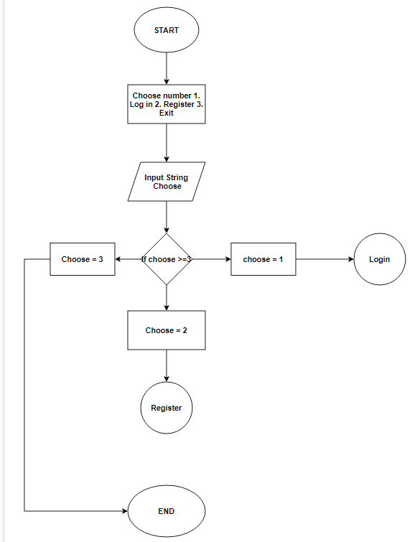**Flowchart**

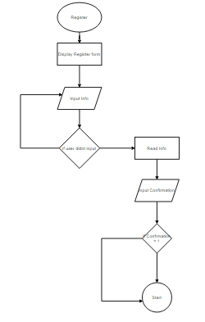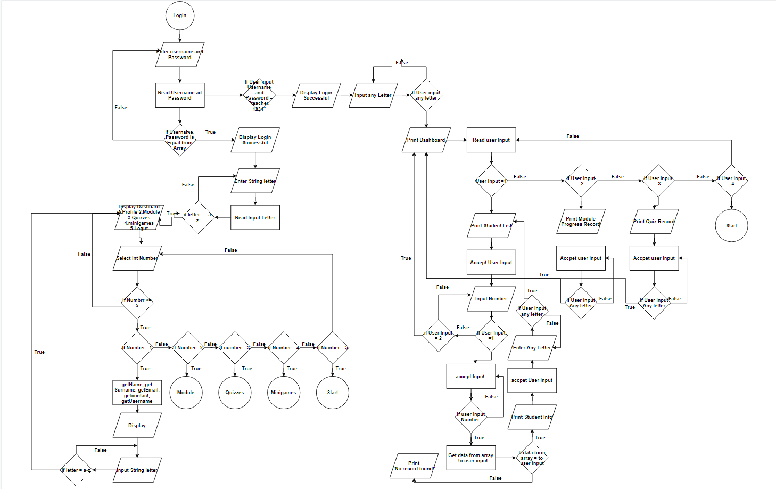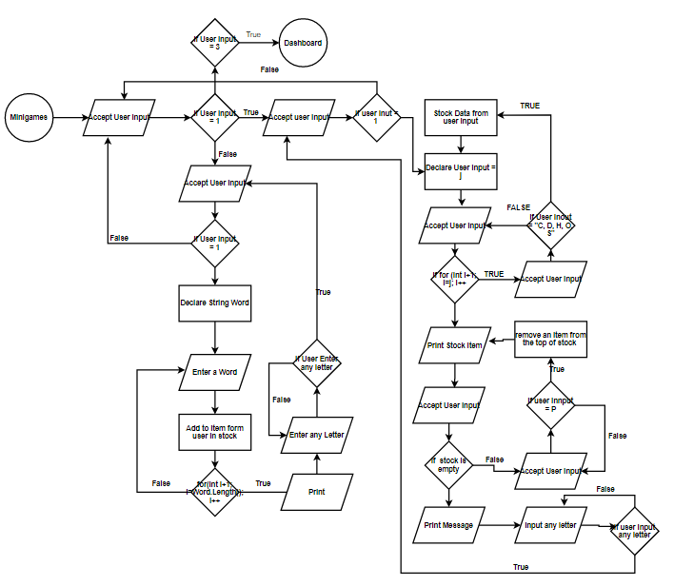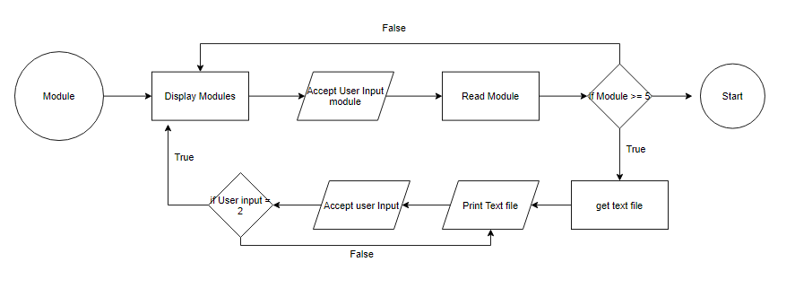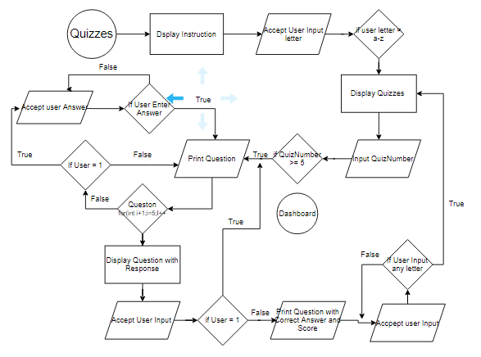

1. **Codes of the System**

**1.Estudy**

**import java.util.*;**

**public class Estudy{**

**static Scanner xd = new Scanner(System.in);**

**static Storing get = new Storing();**

**public static void main(String args[]){**

**for(int s = 0; s < 50; s++) System.out.println();**

**do{**

**System.out.println("\nWelcome to Estudy!");**

**System.out.println("\n[1] Log-in");**

**System.out.println("[2] Register");**

**System.out.println("[3] Exit");**

**System.out.print("\nOption: ");**

**char pick = xd.next().charAt(0);**

**for(int s = 0; s < 50; s++) System.out.println();**

**if(pick == '1'){**

**System.out.println("\nLog-in");**

**System.out.println("\nPlease enter your Username and Password below");**

**System.out.print("Username: ");**

**String user = xd.next();**

**System.out.print("Password: ");**

**String pass = xd.next();**

**Login log = new Login();**

**log.verify1(user, pass);**

**}**

**else if(pick == '2'){**

**register();**

**}**

**else if(pick == '3'){**

**System.out.println("\nThank you! Bye!");**

**System.exit(0);**

**}**

**else{**

**System.out.println("\nPlease Pick a Number Again");**

**}**

**}while(true);**

**}**

**public static void register(){**

**System.out.println("\nRegister");**

**System.out.println("\nPlease enter the following:");**

**System.out.print("Name: ");**

**String name = xd.next();**

**System.out.print("Surname: ");**

**String surname = xd.next();**

**System.out.print("Email: ");**

**String email = xd.next();**

**System.out.print("Contact number: ");**

**String contact = xd.next();**

**System.out.print("Username: ");**

**String username = xd.next();**

**System.out.print("Password: ");**

**String password = xd.next();**

**do{**

**System.out.println("\nDouble check your datails before you submit");**

**System.out.println("[1] Submit");**

**System.out.println("[2] Cancel");**

**System.out.print("\nOption: ");**

**char pick = xd.next().charAt(0);**

**if(pick == '1'){**

**Storing put = new Storing(name, surname, email, contact, username, password);**

**for(int s = 0; s < 50; s++) System.out.println();**

**System.out.println("Saved");**

**break;**

**}**

**else if(pick == '2'){**

**for(int s = 0; s < 50; s++) System.out.println();**

**System.out.println("Cancelled");**

**break;**

**}**

**else{**

**for(int s = 0; s < 50; s++) System.out.println();**

**System.out.println("invalid. Please Pick a Number Again");**

**}**

**}while(true);**

**}**

**}**

**2.Storing**

**import java.util.*;**

**public class Storing extends Estudy{**

**static LinkedList<String> Name = new LinkedList<>();**

**static LinkedList<String> Surname = new LinkedList<>();**

**static LinkedList<String> Email = new LinkedList<>();**

**static LinkedList<String> Contact = new LinkedList<>();**

**static LinkedList<String> Username = new LinkedList<>();**

**static LinkedList<String> Password = new LinkedList<>();**

**static ArrayList<Integer> Progress1 = new ArrayList<>();**

**static ArrayList<Integer> Progress2 = new ArrayList<>();**

**static ArrayList<Integer> Progress3 = new ArrayList<>();**

**static ArrayList<Integer> Progress4 = new ArrayList<>();**

**static ArrayList<Integer> Progress5 = new ArrayList<>();**

**static ArrayList<Character> Quiz11 = new ArrayList<>();**

**static ArrayList<Character> Quiz12 = new ArrayList<>();**

**static ArrayList<Character> Quiz13 = new ArrayList<>();**

**static ArrayList<Character> Quiz14 = new ArrayList<>();**

**static ArrayList<Character> Quiz15 = new ArrayList<>();**

**static ArrayList<Character> Quiz21 = new ArrayList<>();**

**static ArrayList<Character> Quiz22 = new ArrayList<>();**

**static ArrayList<Character> Quiz23 = new ArrayList<>();**

**static ArrayList<Character> Quiz24 = new ArrayList<>();**

**static ArrayList<Character> Quiz25 = new ArrayList<>();**

**static ArrayList<Character> Quiz31 = new ArrayList<>();**

**static ArrayList<Character> Quiz32 = new ArrayList<>();**

**static ArrayList<Character> Quiz33 = new ArrayList<>();**

**static ArrayList<Character> Quiz34 = new ArrayList<>();**

**static ArrayList<Character> Quiz35 = new ArrayList<>();**

**static ArrayList<Character> Quiz41 = new ArrayList<>();**

**static ArrayList<Character> Quiz42 = new ArrayList<>();**

**static ArrayList<Character> Quiz43 = new ArrayList<>();**

**static ArrayList<Character> Quiz44 = new ArrayList<>();**

**static ArrayList<Character> Quiz45 = new ArrayList<>();**

**static ArrayList<Character> Quiz51 = new ArrayList<>();**

**static ArrayList<Character> Quiz52 = new ArrayList<>();**

**static ArrayList<Character> Quiz53 = new ArrayList<>();**

**static ArrayList<Character> Quiz54 = new ArrayList<>();**

**static ArrayList<Character> Quiz55 = new ArrayList<>();**

**static ArrayList<Integer> Score1 = new ArrayList<>();**

**static ArrayList<Integer> Score2 = new ArrayList<>();**

**static ArrayList<Integer> Score3 = new ArrayList<>();**

**static ArrayList<Integer> Score4 = new ArrayList<>();**

**static ArrayList<Integer> Score5 = new ArrayList<>();**

**static ArrayList<Integer> QTake1 = new ArrayList<>();**

**static ArrayList<Integer> QTake2 = new ArrayList<>();**

**static ArrayList<Integer> QTake3 = new ArrayList<>();**

**static ArrayList<Integer> QTake4 = new ArrayList<>();**

**static ArrayList<Integer> QTake5 = new ArrayList<>();**

**Storing(){**

**}**

**Storing(String name, String surname, String email, String contact, String username, String password){**

**Name.add(name);**

**Surname.add(surname);**

**Email.add(email);**

**Contact.add(contact);**

**Username.add(username);**

**Password.add(password);**

**Progress1.add(0);**

**Progress2.add(0);**

**Progress3.add(0);**

**Progress4.add(0);**

**Progress5.add(0);**

**Quiz11.add(' ');**

**Quiz12.add(' ');**

**Quiz13.add(' ');**

**Quiz14.add(' ');**

**Quiz15.add(' ');**

**Quiz21.add(' ');**

**Quiz22.add(' ');**

**Quiz23.add(' ');**

**Quiz24.add(' ');**

**Quiz25.add(' ');**

**Quiz31.add(' ');**

**Quiz32.add(' ');**

**Quiz33.add(' ');**

**Quiz34.add(' ');**

**Quiz35.add(' ');**

**Quiz41.add(' ');**

**Quiz42.add(' ');**

**Quiz43.add(' ');**

**Quiz44.add(' ');**

**Quiz45.add(' ');**

**Quiz51.add(' ');**

**Quiz52.add(' ');**

**Quiz53.add(' ');**

**Quiz54.add(' ');**

**Quiz55.add(' ');**

**Score1.add(0);**

**Score2.add(0);**

**Score3.add(0);**

**Score4.add(0);**

**Score5.add(0);**

**QTake1.add(0);**

**QTake2.add(0);**

**QTake3.add(0);**

**QTake4.add(0);**

**QTake5.add(0);**

**}**

**}**

**3.Log- in**

**import java.util.*;**

**public class Login extends Estudy{**

**static Scanner xd = new Scanner(System.in);**

**static Storing get = new Storing();**

**static int index = 0;**

**public static void verify1(String user, String pass){**

**if(user.equals("Teacher") && pass.equals("1234")){**

**for(int s = 0; s < 50; s++) System.out.println();**

**Teacher teach = new Teacher();**

**teach.monitor();**

**}**

**else{**

**verify2(user, pass);**

**}**

**}**

**public static void verify2(String user, String pass){**

**if(get.Username.contains(user)){**

**do{**

**if(user.equals(get.Username.get(index))){**

**verify3(pass);**

**break;**

**}**

**else{**

**index++;**

**}**

**}while(true);**

**}**

**else{**

**for(int s = 0; s < 50; s++) System.out.println();**

**System.out.println("\nIncorrect Username or Password");**

**}**

**}**

**public static void verify3(String pass){**

**if(pass.equals(get.Password.get(index))){**

**for(int s = 0; s < 50; s++) System.out.println();**

**System.out.println("\nLogin Successful");**

**System.out.println("\nWelcome, " + get.Name.get(index) + "!");**

**System.out.print("\n[enter any key] ");**

**char pick = xd.next().charAt(0);**

**for(int s = 0; s < 50; s++) System.out.println();**

**Student stud = new Student();**

**stud.dashboard(index);**

**index -= index;**

**}**

**else{**

**for(int s = 0; s < 50; s++) System.out.println();**

**System.out.println("\nIncorrect Username or Password");**

**index -= index;**

**}**

**}**

**}**

**4.Teacher**

**import java.util.*;**

**public class Teacher extends Login{**

**static Scanner xd = new Scanner(System.in);**

**static Storing get = new Storing();**

**static PriorityQueue<String> priority = new PriorityQueue<>();**

**static String alpha;**

**static int index = 0;**

**static int count = 0;**

**public static void monitor(){**

**do{**

**System.out.println("\nDashboard");**

**System.out.println("[1] Students' Info");**

**System.out.println("[2] Modules' Progress");**

**System.out.println("[3] Quizzes' Scores");**

**System.out.println("[4] Log-out");**

**System.out.print("\nOption: ");**

**char pick = xd.next().charAt(0);**

**for(int s = 0; s < 50; s++) System.out.println();**

**if(pick == '1'){**

**sInfo();**

**}**

**else if(pick == '2'){**

**mProgress();**

**}**

**else if(pick == '3'){**

**qScores();**

**}**

**else if(pick == '4'){**

**System.out.println("Logged out Successfuly");**

**break;**

**}**

**else{**

**System.out.println("Please Pick a Correct Number");**

**}**

**}while(true);**

**}**

**public static void sInfo(){**

**do{**

**System.out.println("\nStudent list\n");**

**for(String surname: get.Surname){**

**priority.offer(surname);**

**}**

**count -= count;**

**while(!priority.isEmpty()){**

**alpha = priority.poll();**

**alphabet(alpha);**

**}**

**System.out.println("\n[1] To see details");**

**System.out.println("[2] Exit");**

**System.out.print("\nOption: ");**

**char pick = xd.next().charAt(0);**

**if(pick == '1'){**

**info();**

**}**

**else if(pick == '2'){**

**for(int s = 0; s < 50; s++) System.out.println();**

**System.out.println("\nExit Successfuly");**

**break;**

**}**

**else{**

**for(int s = 0; s < 50; s++) System.out.println();**

**System.out.println("\nPick a Number Again");**

**}**

**}while(true);**

**}**

**public static void alphabet(String alpha){**

**do{**

**if(get.Surname.get(index).equals(alpha)){**

**count++;**

**System.out.println(count + ". " + get.Surname.get(index) + ", " + get.Name.get(index));**

**System.out.println("----------------------");**

**index -= index;**

**break;**

**}**

**else{**

**index++;**

**}**

**}while(true);**

**}**

**public static void info(){**

**do{**

**try{**

**System.out.println("\nChoose the number of the student you want to see the details");**

**System.out.print("\nStudent Number: ");**

**int pick = xd.nextInt();**

**for(int s = 0; s < 50; s++) System.out.println();**

**if(pick > 0 && pick <= get.Surname.size()){**

**nfo(pick);**

**System.out.print("\n[enter any key} ");**

**char any = xd.next().charAt(0);**

**for(int s = 0; s < 50; s++) System.out.println();**

**break;**

**}**

**else{**

**System.out.println("\nPick a number of the student again");**

**}**

**}catch(Exception e){**

**for(int s = 0; s < 50; s++) System.out.println();**

**System.out.println("\nSorry, Please Pick a Number");**

**xd.nextLine();**

**}**

**}while(true);**

**}**

**public static void nfo(int pick){**

**String cho = " ";**

**for(String surname: get.Surname){**

**priority.offer(surname);**

**}**

**for(int i = 1; i <= pick; i++){**

**cho = priority.poll();**

**}**

**do{**

**if(get.Surname.get(index).equals(cho)){**

**System.out.println("\nDetails:");**

**System.out.println("\nStudent Name: " + get.Name.get(index));**

**System.out.println("\nStudent Surname: " + get.Surname.get(index));**

**System.out.println("\nStudent Email: " + get.Email.get(index));**

**System.out.println("\nStudent Contact Number: " + get.Contact.get(index));**

**System.out.println("\nStudent Username: " + get.Username.get(index));**

**index -= index;**

**break;**

**}**

**else{**

**index++;**

**}**

**}while(true);**

**}**

**public static void mProgress(){**

**System.out.println("\nModule Progress Record");**

**System.out.println("\nNames \t\t\t\t\t Computer \t\tData Structure" +**

**"\t\tHuman-Computer \tObject Oriented \tSystem Administration ");**

**System.out.println(" \t\t\t\t\tProgramming \tand Algorithms" +**

**"\t\tInteraction \t\tProgramming \t\tand Maintenance");**

**System.out.println("------------------------------------------------------"+**

**"----------------------------------------------------------------------");**

**for(String surname: get.Surname){**

**priority.offer(surname);**

**}**

**while(!priority.isEmpty()){**

**alpha = priority.poll();**

**progress(alpha);**

**}**

**System.out.print("\n\n[enter any key] ");**

**char any = xd.next().charAt(0);**

**for(int s = 0; s < 50; s++) System.out.println();**

**}**

**public static void progress(String alpha){**

**do{**

**if(get.Surname.get(index).equals(alpha)){**

**System.out.println("\n" + get.Surname.get(index) +", "+ get.Name.get(index));**

**System.out.println("\t\t\t\t\t\t\t "+ get.Progress1.get(index) +"% \t\t\t"+ get.Progress2.get(index)**

**+"% \t\t\t\t\t"+ get.Progress3.get(index) +"% \t\t\t\t\t"+ get.Progress4.get(index) +"% \t\t\t\t\t"**

**+ get.Progress5.get(index) +"%");**

**System.out.println("------------------------------------------------------"+**

**"----------------------------------------------------------------------");**

**index -= index;**

**break;**

**}**

**else{**

**index++;**

**}**

**}while(true);**

**}**

**public static void qScores(){**

**System.out.println("\nQuiz Record");**

**System.out.println("\nNames \t\t\t\t\t Quiz1 \t\tQuiz2 \t\tQuiz3 \t\tQuiz4 \t\tQuiz5");**

**System.out.println("--------------------------------------------------------------------------------------");**

**for(String surname: get.Surname){**

**priority.offer(surname);**

**}**

**while(!priority.isEmpty()){**

**alpha = priority.poll();**

**score(alpha);**

**}**

**System.out.print("\n\n[enter any key] ");**

**char any = xd.next().charAt(0);**

**for(int s = 0; s < 50; s++) System.out.println();**

**}**

**public static void score(String alpha){**

**do{**

**if(get.Surname.get(index).equals(alpha)){**

**System.out.println("\n" + get.Surname.get(index) +", "+ get.Name.get(index));**

**System.out.println("\t\t\t\t\t\t "+ get.Score1.get(index) +"/10 \t\t"+ get.Score2.get(index) +"/10 \t\t"+**

**get.Score3.get(index) +"/10 \t\t"+ get.Score4.get(index) +"/10 \t\t"+ get.Score5.get(index) +"/10");**

**System.out.println("--------------------------------------------------------------------------------------");**

**index -= index;**

**break;**

**}**

**else{**

**index++;**

**}**

**}while(true);**

**}**

**}**

**5. Student**

**import java.util.*;**

**public class Student extends Login{**

**static Scanner xd = new Scanner(System.in);**

**static Storing get = new Storing();**

**public static void dashboard(int index){**

**do{**

**System.out.println("\nDashboard");**

**System.out.println("[1] Profile");**

**System.out.println("[2] Modules");**

**System.out.println("[3] Quizzes");**

**System.out.println("[4] Minigames");**

**System.out.println("[5] Log-out");**

**System.out.print("\nOption: ");**

**char pick = xd.next().charAt(0);**

**for(int s = 0; s < 50; s++) System.out.println();**

**if(pick == '1'){**

**System.out.println("\nDetails:");**

**System.out.println("\nStudent Name: " + get.Name.get(index));**

**System.out.println("\nStudent Surname: " + get.Surname.get(index));**

**System.out.println("\nStudent Email: " + get.Email.get(index));**

**System.out.println("\nStudent Contact Number: " + get.Contact.get(index));**

**System.out.println("\nStudent Username: " + get.Username.get(index));**

**System.out.print("\n\n[enter any key] ");**

**char any = xd.next().charAt(0);**

**for(int s = 0; s < 50; s++) System.out.println();**

**}**

**else if(pick == '2'){**

**Modules mod = new Modules();**

**mod.handouts(index);**

**}**

**else if(pick == '3'){**

**System.out.println("\nInstruction:");**

**System.out.println("\nYou can only take the quiz once.");**

**System.out.println("Once you open the quiz, you cannot cancel or exit it.");**

**System.out.println("There is no time taking the quiz.");**

**System.out.println("Lower case Letter is considered wrong.");**

**System.out.println("You can review and edit your answers before you submit.");**

**System.out.print("\n[enter any key] ");**

**pick = xd.next().charAt(0);**

**for(int s = 0; s < 50; s++) System.out.println();**

**Quizzes qui = new Quizzes();**

**qui.quiz(index);**

**}**

**else if(pick == '4'){**

**Games game = new Games();**

**game.gameMenu();**

**}**

**else if(pick == '5'){**

**System.out.println("Logged out successfuly");**

**break;**

**}**

**else{**

**System.out.println("\nInvalid Syntax");**

**}**

**}while(true);**

**}**

**}**

**6. Modules**

**import java.util.*;**

**public class Modules extends Student{**

**static Scanner xd = new Scanner(System.in);**

**static Handouts handout = new Handouts();**

**static Storing get = new Storing();**

**static Progress prog = new Progress();**

**static int pageNum;**

**static String path;**

**public static void handouts(int index){**

**do{**

**try{**

**System.out.println("\nWhat do you want to browse?");**

**System.out.println("[1] Computer Programming \tProgress: " + get.Progress1.get(index) + "%");**

**System.out.println("[2] Data Structure and Algorithms \tProgress: " + get.Progress2.get(index) + "%");**

**System.out.println("[3] Human-Computer Interaction \tProgress: " + get.Progress3.get(index) + "%");**

**System.out.println("[4] Object Oriented Programming \tProgress: " + get.Progress4.get(index) + "%");**

**System.out.println("[5] System Administration and Maintenance \tProgress: " + get.Progress5.get(index) + "%");**

**System.out.println("[6] Exit");**

**System.out.print("\nOption: ");**

**int pick = xd.nextInt();**

**for(int s = 0; s < 50; s++) System.out.println();**

**if(pick > 0 && pick < 6){**

**pick -= 1;**

**page1(index, pick);**

**}**

**else if(pick == 6){**

**System.out.println("\nExit Successfuly");**

**break;**

**}**

**else{**

**System.out.println("\nPick a Number Again");**

**}**

**}catch(Exception e){**

**System.out.println("\nSorry, Please Pick a Number.");**

**xd.nextLine();**

**}**

**}while(true);**

**}**

**public static void page1(int index, int handNum){**

**pageNum = 1;**

**prog.progress(index, handNum, pageNum);**

**path = handout.page1[handNum];**

**handout.read(path);**

**System.out.println("\n[1] Next");**

**System.out.println("[2] Exit");**

**System.out.print("\nOption: ");**

**char pick = xd.next().charAt(0);**

**for(int s = 0; s < 50; s++) System.out.println();**

**if(pick == '1'){**

**page2(index, handNum);**

**}**

**else if(pick == '2'){**

**System.out.println("\nExit Successfuly");**

**}**

**else{**

**System.out.println("\nPlease Pick a Number Again");**

**page1(index, handNum);**

**}**

**}**

**public static void page2(int index, int handNum){**

**pageNum = 2;**

**prog.progress(index, handNum, pageNum);**

**path = handout.page2[handNum];**

**handout.read(path);**

**System.out.println("\n[1] Next");**

**System.out.println("[2] Previous");**

**System.out.println("[3] Exit");**

**System.out.print("\nOption: ");**

**char pick = xd.next().charAt(0);**

**for(int s = 0; s < 50; s++) System.out.println();**

**if(pick == '1'){**

**page3(index, handNum);**

**}**

**else if(pick == '2'){**

**page1(index, handNum);**

**}**

**else if(pick == '3'){**

**System.out.println("\nExit Successfuly");**

**}**

**else{**

**System.out.println("\nInvalid Syntax");**

**page2(index, handNum);**

**}**

**}**

**public static void page3(int index, int handNum){**

**pageNum = 3;**

**prog.progress(index, handNum, pageNum);**

**path = handout.page3[handNum];**

**handout.read(path);**

**System.out.println("\n[1] Next");**

**System.out.println("[2] Previous");**

**System.out.println("[3] Exit");**

**System.out.print("\nOption: ");**

**char pick = xd.next().charAt(0);**

**for(int s = 0; s < 50; s++) System.out.println();**

**if(pick == '1'){**

**page4(index, handNum);**

**}**

**else if(pick == '2'){**

**page2(index, handNum);**

**}**

**else if(pick == '3'){**

**System.out.println("\nExit Successfuly");**

**}**

**else{**

**System.out.println("\nInvalid Syntax");**

**page3(index, handNum);**

**}**

**}**

**public static void page4(int index, int handNum){**

**pageNum = 4;**

**prog.progress(index, handNum, pageNum);**

**path = handout.page4[handNum];**

**handout.read(path);**

**System.out.println("\n[1] Next");**

**System.out.println("[2] Previous");**

**System.out.println("[3] Exit");**

**System.out.print("\nOption: ");**

**char pick = xd.next().charAt(0);**

**for(int s = 0; s < 50; s++) System.out.println();**

**if(pick == '1'){**

**page5(index, handNum);**

**}**

**else if(pick == '2'){**

**page3(index, handNum);**

**}**

**else if(pick == '3'){**

**System.out.println("\nExit Successfuly");**

**}**

**else{**

**System.out.println("\nInvalid Syntax");**

**page4(index, handNum);**

**}**

**}**

**public static void page5(int index, int handNum){**

**pageNum = 5;**

**prog.progress(index, handNum, pageNum);**

**path = handout.page5[handNum];**

**handout.read(path);**

**System.out.println("\n[1] Previous");**

**System.out.println("[2] Exit");**

**System.out.print("\nOption: ");**

**char pick = xd.next().charAt(0);**

**for(int s = 0; s < 50; s++) System.out.println();**

**if(pick == '1'){**

**page4(index, handNum);**

**}**

**else if(pick == '2'){**

**System.out.println("\nExit Successfuly");**

**}**

**else{**

**System.out.println("\nInvalid Syntax");**

**page5(index, handNum);**

**}**

**}**

**}**

**7. Handouts**

**import java.io.File;**

**import java.io.FileNotFoundException;**

**import java.util.Scanner;**

**public class Handouts extends Modules{**

**static String[] page1 = {"C:/Users/Ranie/Desktop/System/Handouts/01 Handouts 1.txt",**

**"C:/Users/Ranie/Desktop/System/Handouts/02 Handouts 1.txt",**

**"C:/Users/Ranie/Desktop/System/Handouts/03 Handouts 1.txt",**

**"C:/Users/Ranie/Desktop/System/Handouts/04 Handouts 1.txt",**

**"C:/Users/Ranie/Desktop/System/Handouts/05 Handouts 1.txt"};**

**static String[] page2 = {"C:/Users/Ranie/Desktop/System/Handouts/01 Handouts 2.txt",**

**"C:/Users/Ranie/Desktop/System/Handouts/02 Handouts 2.txt",**

**"C:/Users/Ranie/Desktop/System/Handouts/03 Handouts 2.txt",**

**"C:/Users/Ranie/Desktop/System/Handouts/04 Handouts 2.txt",**

**"C:/Users/Ranie/Desktop/System/Handouts/05 Handouts 2.txt"};**

**static String[] page3 = {"C:/Users/Ranie/Desktop/System/Handouts/01 Handouts 3.txt",**

**"C:/Users/Ranie/Desktop/System/Handouts/02 Handouts 3.txt",**

**"C:/Users/Ranie/Desktop/System/Handouts/03 Handouts 3.txt",**

**"C:/Users/Ranie/Desktop/System/Handouts/04 Handouts 3.txt",**

**"C:/Users/Ranie/Desktop/System/Handouts/05 Handouts 3.txt"};**

**static String[] page4 = {"C:/Users/Ranie/Desktop/System/Handouts/01 Handouts 4.txt",**

**"C:/Users/Ranie/Desktop/System/Handouts/02 Handouts 4.txt",**

**"C:/Users/Ranie/Desktop/System/Handouts/03 Handouts 4.txt",**

**"C:/Users/Ranie/Desktop/System/Handouts/04 Handouts 4.txt",**

**"C:/Users/Ranie/Desktop/System/Handouts/05 Handouts 4.txt"};**

**static String[] page5 = {"C:/Users/Ranie/Desktop/System/Handouts/01 Handouts 5.txt",**

**"C:/Users/Ranie/Desktop/System/Handouts/02 Handouts 5.txt",**

**"C:/Users/Ranie/Desktop/System/Handouts/03 Handouts 5.txt",**

**"C:/Users/Ranie/Desktop/System/Handouts/04 Handouts 5.txt",**

**"C:/Users/Ranie/Desktop/System/Handouts/05 Handouts 5.txt"};**

**Handouts(){**

**}**

**public static void read(String path){**

**try{**

**File file = new File(path);**

**Scanner scan = new Scanner(file);**

**while(scan.hasNextLine()){**

**System.out.println(scan.nextLine());**

**}**

**}catch(Exception e){**

**System.out.println("\nFile cannot find");**

**}**

**}**

**}**

**8. Progress**

**public class Progress extends Modules{**

**public static void progress(int index, int handNum, int pageNum){**

**Storing get = new Storing();**

**int prog;**

**int total;**

**handNum += 1;**

**if(handNum == 1){**

**prog = get.Progress1.get(index);**

**total = percent(pageNum, prog);**

**get.Progress1.set(index, total);**

**}**

**else if(handNum == 2){**

**prog = get.Progress2.get(index);**

**total = percent(pageNum, prog);**

**get.Progress2.set(index, total);**

**}**

**else if(handNum == 3){**

**prog = get.Progress3.get(index);**

**total = percent(pageNum, prog);**

**get.Progress3.set(index, total);**

**}**

**else if(handNum == 4){**

**prog = get.Progress4.get(index);**

**total = percent(pageNum, prog);**

**get.Progress4.set(index, total);**

**}**

**else if(handNum == 5){**

**prog = get.Progress5.get(index);**

**total = percent(pageNum, prog);**

**get.Progress5.set(index, total);**

**}**

**}**

**public static int percent(int pageNum, int prog){**

**if (pageNum == 1 && prog < 20){**

**prog += 20;**

**}**

**else if (pageNum == 2 && prog < 40){**

**prog += 20;;**

**}**

**else if (pageNum == 3 && prog < 60){**

**prog += 20;**

**}**

**else if (pageNum == 4 && prog < 80){**

**prog += 20;**

**}**

**else if (pageNum == 5 && prog < 100){**

**prog += 20;**

**}**

**return prog;**

**}**

**}**

**9. Quizzes**

**import java.util.*;**

**public class Quizzes extends Modules{**

**static Scanner xd = new Scanner(System.in);**

**static Storing get = new Storing();**

**static Questions question = new Questions();**

**static Answers answer = new Answers();**

**static char ans;**

**static char cho;**

**public static void quiz(int Index){**

**do{**

**try{**

**System.out.println("\nWhat do you want to take?");**

**System.out.println("[1] Quiz 1");**

**System.out.println("[2] Quiz 2");**

**System.out.println("[3] Quiz 3");**

**System.out.println("[4] Quiz 4");**

**System.out.println("[5] Quiz 5");**

**System.out.println("[6] Exit");**

**System.out.print("\nOption: ");**

**int pick = xd.nextInt();**

**for(int s = 0; s < 50; s++) System.out.println();**

**if(pick > 0 && pick < 6){**

**take(index, pick);**

**}**

**else if(pick == 6){**

**System.out.println("\nExit Successfuly");**

**break;**

**}**

**else{**

**System.out.println("\nPick a Number Again");**

**}**

**}catch(Exception e){**

**System.out.println("\nSorry, Please Pick a Number.");**

**xd.nextLine();**

**}**

**}while(true);**

**}**

**public static void take(int index, int quizNum){**

**if(get.QTake1.get(index) == quizNum || get.QTake2.get(index) == quizNum ||**

**get.QTake3.get(index) == quizNum || get.QTake4.get(index) == quizNum ||**

**get.QTake5.get(index) == quizNum){**

**do{**

**System.out.println("\nYou already take this quiz");**

**System.out.println("[1] Review the quiz");**

**System.out.println("[2] Exit");**

**System.out.print("\nOption: ");**

**char pick = xd.next().charAt(0);**

**for(int s = 0; s < 50; s++) System.out.println();**

**if(pick == '1'){**

**Checker check = new Checker();**

**quizNum -= 1;**

**check.result(index, quizNum);**

**break;**

**}**

**else if(pick == '2'){**

**System.out.println("\nExit Successfuly");**

**break;**

**}**

**else{**

**System.out.println("Please Pick a Correct Number Again");**

**}**

**}while(true);**

**}**

**else{**

**quizNum -= 1;**

**number1(index, quizNum);**

**}**

**}**

**public static void number1(int index, int quizNum){**

**do{**

**System.out.println("\n" + question.Q1[quizNum]);**

**System.out.println("A) " + question.C1[quizNum][0]);**

**System.out.println("B) " + question.C1[quizNum][1]);**

**System.out.println("C) " + question.C1[quizNum][2]);**

**System.out.println("D) " + question.C1[quizNum][3]);**

**System.out.println("\nResponse: " + answer.one(index, quizNum));**

**System.out.println("\n[1] Answer");**

**System.out.println("[2] Next");**

**System.out.print("\nOption: ");**

**cho = xd.next().charAt(0);**

**if(cho == '1'){**

**System.out.print("\nAnswer: ");**

**ans = xd.next().charAt(0);**

**answer.setOne(index, quizNum, ans);**

**for(int s = 0; s < 50; s++) System.out.println();**

**}**

**else if(cho == '2'){**

**for(int s = 0; s < 50; s++) System.out.println();**

**number2(index, quizNum);**

**break;**

**}**

**else{**

**for(int s = 0; s < 50; s++) System.out.println();**

**System.out.println("\nPlease Pick a Correct Number Again");**

**}**

**}while(true);**

**}**

**public static void number2(int index, int quizNum){**

**do{**

**System.out.println("\n" + question.Q2[quizNum]);**

**System.out.println("A) " + question.C2[quizNum][0]);**

**System.out.println("B) " + question.C2[quizNum][1]);**

**System.out.println("C) " + question.C2[quizNum][2]);**

**System.out.println("D) " + question.C2[quizNum][3]);**

**System.out.println("\nResponse: " + answer.two(index, quizNum));**

**System.out.println("\n[1] Answer");**

**System.out.println("[2] Next");**

**System.out.println("[3] Previous");**

**System.out.print("\nOption: ");**

**cho = xd.next().charAt(0);**

**if(cho == '1'){**

**System.out.print("\nAnswer: ");**

**ans = xd.next().charAt(0);**

**answer.setTwo(index, quizNum, ans);**

**for(int s = 0; s < 50; s++) System.out.println();**

**}**

**else if(cho == '2'){**

**for(int s = 0; s < 50; s++) System.out.println();**

**number3(index, quizNum);**

**break;**

**}**

**else if(cho == '3'){**

**for(int s = 0; s < 50; s++) System.out.println();**

**number1(index, quizNum);**

**break;**

**}**

**else{**

**for(int s = 0; s < 50; s++) System.out.println();**

**System.out.println("\nPlease Pick a Correct Number Again");**

**}**

**}while(true);**

**}**

**public static void number3(int index, int quizNum){**

**do{**

**System.out.println("\n" + question.Q3[quizNum]);**

**System.out.println("A) " + question.C3[quizNum][0]);**

**System.out.println("B) " + question.C3[quizNum][1]);**

**System.out.println("C) " + question.C3[quizNum][2]);**

**System.out.println("D) " + question.C3[quizNum][3]);**

**System.out.println("\nResponse: " + answer.three(index, quizNum));**

**System.out.println("\n[1] Answer");**

**System.out.println("[2] Next");**

**System.out.println("[3] Previous");**

**System.out.print("\nOption: ");**

**cho = xd.next().charAt(0);**

**if(cho == '1'){**

**System.out.print("\nAnswer: ");**

**ans = xd.next().charAt(0);**

**answer.setThree(index, quizNum, ans);**

**for(int s = 0; s < 50; s++) System.out.println();**

**}**

**else if(cho == '2'){**

**for(int s = 0; s < 50; s++) System.out.println();**

**number4(index, quizNum);**

**break;**

**}**

**else if(cho == '3'){**

**for(int s = 0; s < 50; s++) System.out.println();**

**number2(index, quizNum);**

**break;**

**}**

**else{**

**for(int s = 0; s < 50; s++) System.out.println();**

**System.out.println("\nPlease Pick a Correct Number Again");**

**}**

**}while(true);**

**}**

**public static void number4(int index, int quizNum){**

**do{**

**System.out.println("\n" + question.Q4[quizNum]);**

**System.out.println("A) " + question.C4[quizNum][0]);**

**System.out.println("B) " + question.C4[quizNum][1]);**

**System.out.println("C) " + question.C4[quizNum][2]);**

**System.out.println("D) " + question.C4[quizNum][3]);**

**System.out.println("\nResponse: " + answer.four(index, quizNum));**

**System.out.println("\n[1] Answer");**

**System.out.println("[2] Next");**

**System.out.println("[3] Previous");**

**System.out.print("\nOption: ");**

**cho = xd.next().charAt(0);**

**if(cho == '1'){**

**System.out.print("\nAnswer: ");**

**ans = xd.next().charAt(0);**

**answer.setFour(index, quizNum, ans);**

**for(int s = 0; s < 50; s++) System.out.println();**

**}**

**else if(cho == '2'){**

**for(int s = 0; s < 50; s++) System.out.println();**

**number5(index, quizNum);**

**break;**

**}**

**else if(cho == '3'){**

**for(int s = 0; s < 50; s++) System.out.println();**

**number3(index, quizNum);**

**break;**

**}**

**else{**

**for(int s = 0; s < 50; s++) System.out.println();**

**System.out.println("\nPlease Pick a Correct Number Again");**

**}**

**}while(true);**

**}**

**public static void number5(int index, int quizNum){**

**do{**

**System.out.println("\n" + question.Q5[quizNum]);**

**System.out.println("A) " + question.C5[quizNum][0]);**

**System.out.println("B) " + question.C5[quizNum][1]);**

**System.out.println("C) " + question.C5[quizNum][2]);**

**System.out.println("D) " + question.C5[quizNum][3]);**

**System.out.println("\nResponse: " + answer.five(index, quizNum));**

**System.out.println("\n[1] Answer");**

**System.out.println("[2] Previous");**

**System.out.println("[3] Done");**

**System.out.print("\nOption: ");**

**cho = xd.next().charAt(0);**

**if(cho == '1'){**

**System.out.print("\nAnswer: ");**

**ans = xd.next().charAt(0);**

**answer.setFive(index, quizNum, ans);**

**for(int s = 0; s < 50; s++) System.out.println();**

**}**

**else if(cho == '2'){**

**for(int s = 0; s < 50; s++) System.out.println();**

**number4(index, quizNum);**

**break;**

**}**

**else if(cho == '3'){**

**for(int s = 0; s < 50; s++) System.out.println();**

**Checker check = new Checker();**

**check.review(index, quizNum);**

**break;**

**}**

**else{**

**for(int s = 0; s < 50; s++) System.out.println();**

**System.out.println("\nPlease Pick a Correct Number Again");**

**}**

**}while(true);**

**}**

**}**

**10. Questions**

**import java.util.*;**

**public class Questions extends Quizzes{**

**static String[] Q1 = {"1. It is a process of planning and creating a program.",**

**"1. It represents a hierarchical nature of a structure in a graphical form.",**

**"1. Commonly known as “user-centered design.",**

**"1. It is a programming methodology that defines objects whose behaviors and interactions accomplish a given task.",**

**"1. Which of these is not included in the CATEGORIES?"};**

**static String[] Q2 = {"2. It is a sequence of statements intended to accomplish a certain task.",**

**"2. A collection of elments where each element is unique.",**

**"2. A way to relieve long term memory load of a user is to strive for consistency.",**

**"2. It has characteristics or attributes.",**

**"2. Which of these are contained in DESKTOP DEVELOPERS?"};**

**static String[] Q3 = {"3. It is a problem solving technique used in solving programming problems.",**

**"3. This is a special format for storing and organizing data.",**

**"3. It is important to complete task without any errors.",**

**"3. It is a blueprint for defining the objects.",**

**"3. Command used to zip or compressed a files or to extract a zip file."};**

**static String[] Q4 = {"4. These are the programming languages that use natural language such as english language.",**

**"4. Repeating an actions multiple times.",**

**"4. It refers to an abstact model by which humas interact with the computing device to complete a given task.",**

**"4. This is a program that contains the heading for a number of public methods.",**

**"4. Command to access the ping utility and to check your connection to the server."};**

**static String[] Q5 = {"5. This is a method of describing computer algorithms using combination of natural language and programming language.",**

**"5. A complete binary tree where the value of each of each parent nide is either higher or lower than the value of its child nodes.",**

**"5. It refers to the boundary whrein two independent systems meet an act on or communicate with each other.",**

**"5. This is a collection of related classes and interfaces that have been grouped together into a folder.",**

**"5. Command to work with compressed files such as tarball archive."};**

**static String[][] C1 = {{"Computer Program", "Programming", "Assembler", "Low-level Languages"},**

**{"LinkedList", "Stack", "Heap", "Priority Queue"},**

**{"Remind users", "Know the user", "Understand the task", "Natural Interaction and Interface"},**

**{"Interface", "Class", "Package", "Object-Oriented Programming"},**

**{"System Analysis", "Sytem Software", "Operating System", "Utility Program"}};**

**static String[][] C2 = {{"Machine Language", "Programming", "Assembly Language", "Computer Programming"},**

**{"Map", "Set", "Stack ", "Queue"},**

**{"Remind Users", "Know the User", "Understand the Task", "Strive for Consistency"},**

**{"Interface", "Class", "Pakage", "Object"},**

**{"Gnome", "Sytem Software", "Operating System", "Utility Program"}};**

**static String[][] C3 = {{"Algorithm", "Coding", "Execution", "Problem Analysis"},**

**{"Algorithm", "Graph", "Linear", "Data Structure"},**

**{"Prevent Error/Reversal Action", "Know the User", "Understand the Task", "Remind Users"},**

**{"Interface", "Class", "Pakage", "Object"},**

**{"Zip/Unzip", "Utility Program", "Operating System", "Ping"}};**

**static String[][] C4 = {{"High-Level Language", "Commands", "Compiler", "Interpreter"},**

**{"Interation", "Recursion", "Stack", "Queue"},**

**{"Interface", "Know the User", "Understand the Task", "Interaction"},**

**{"Interface", "Class", "Pakage", "Object"},**

**{"Zip/Unzip", "Tar", "IP Config", "Ping"}};**

**static String[][] C5 = {{"Pseudocode", "Flowchart", "Object-Oriented Programming", "Procedural Programming"},**

**{"Set", "Map", "Heap", "Tree"},**

**{"Interface", "Know the User", "Understand the Task", "Interaction"},**

**{"Interface", "Class", "Pakage", "Object"},**

**{"Zip/Unzip", "Tar", "IP Config", "Ping"}};**

**}**

**11. Answers**

**import java.util.*;**

**public class Answers extends Quizzes{**

**static Storing get = new Storing();**

**static char go;**

**public static char one(int index, int quizNum){**

**if(quizNum == 0){**

**go = get.Quiz11.get(index);**

**}**

**else if(quizNum == 1){**

**go = get.Quiz21.get(index);**

**}**

**else if(quizNum == 2){**

**go = get.Quiz31.get(index);**

**}**

**else if(quizNum == 3){**

**go = get.Quiz41.get(index);**

**}**

**else if(quizNum == 4){**

**go = get.Quiz51.get(index);**

**}**

**return go;**

**}**

**public static char two(int index, int quizNum){**

**if(quizNum == 0){**

**go = get.Quiz12.get(index);**

**}**

**else if(quizNum == 1){**

**go = get.Quiz22.get(index);**

**}**

**else if(quizNum == 2){**

**go = get.Quiz32.get(index);**

**}**

**else if(quizNum == 3){**

**go = get.Quiz42.get(index);**

**}**

**else if(quizNum == 4){**

**go = get.Quiz52.get(index);**

**}**

**return go;**

**}**

**public static char three(int index, int quizNum){**

**if(quizNum == 0){**

**go = get.Quiz13.get(index);**

**}**

**else if(quizNum == 1){**

**go = get.Quiz23.get(index);**

**}**

**else if(quizNum == 2){**

**go = get.Quiz33.get(index);**

**}**

**else if(quizNum == 3){**

**go = get.Quiz43.get(index);**

**}**

**else if(quizNum == 4){**

**go = get.Quiz53.get(index);**

**}**

**return go;**

**}**

**public static char four(int index, int quizNum){**

**if(quizNum == 0){**

**go = get.Quiz14.get(index);**

**}**

**else if(quizNum == 1){**

**go = get.Quiz24.get(index);**

**}**

**else if(quizNum == 2){**

**go = get.Quiz34.get(index);**

**}**

**else if(quizNum == 3){**

**go = get.Quiz44.get(index);**

**}**

**else if(quizNum == 4){**

**go = get.Quiz54.get(index);**

**}**

**return go;**

**}**

**public static char five(int index, int quizNum){**

**if(quizNum == 0){**

**go = get.Quiz15.get(index);**

**}**

**else if(quizNum == 1){**

**go = get.Quiz25.get(index);**

**}**

**else if(quizNum == 2){**

**go = get.Quiz35.get(index);**

**}**

**else if(quizNum == 3){**

**go = get.Quiz45.get(index);**

**}**

**else if(quizNum == 4){**

**go = get.Quiz55.get(index);**

**}**

**return go;**

**}**

**public static void setOne(int index, int quizNum, char ans){**

**if(quizNum == 0){**

**get.Quiz11.set(index, ans);**

**}**

**else if(quizNum == 1){**

**get.Quiz21.set(index, ans);**

**}**

**else if(quizNum == 2){**

**get.Quiz31.set(index, ans);**

**}**

**else if(quizNum == 3){**

**get.Quiz41.set(index, ans);**

**}**

**else if(quizNum == 4){**

**get.Quiz51.set(index, ans);**

**}**

**}**

**public static void setTwo(int index, int quizNum, char ans){**

**if(quizNum == 0){**

**get.Quiz12.set(index, ans);**

**}**

**else if(quizNum == 1){**

**get.Quiz22.set(index, ans);**

**}**

**else if(quizNum == 2){**

**get.Quiz32.set(index, ans);**

**}**

**else if(quizNum == 3){**

**get.Quiz42.set(index, ans);**

**}**

**else if(quizNum == 4){**

**get.Quiz52.set(index, ans);**

**}**

**}**

**public static void setThree(int index, int quizNum, char ans){**

**if(quizNum == 0){**

**get.Quiz13.set(index, ans);**

**}**

**else if(quizNum == 1){**

**get.Quiz23.set(index, ans);**

**}**

**else if(quizNum == 2){**

**get.Quiz33.set(index, ans);**

**}**

**else if(quizNum == 3){**

**get.Quiz43.set(index, ans);**

**}**

**else if(quizNum == 4){**

**get.Quiz53.set(index, ans);**

**}**

**}**

**public static void setFour(int index, int quizNum, char ans){**

**if(quizNum == 0){**

**get.Quiz14.set(index, ans);**

**}**

**else if(quizNum == 1){**

**get.Quiz24.set(index, ans);**

**}**

**else if(quizNum == 2){**

**get.Quiz34.set(index, ans);**

**}**

**else if(quizNum == 3){**

**get.Quiz44.set(index, ans);**

**}**

**else if(quizNum == 4){**

**get.Quiz54.set(index, ans);**

**}**

**}**

**public static void setFive(int index, int quizNum, char ans){**

**if(quizNum == 0){**

**get.Quiz15.set(index, ans);**

**}**

**else if(quizNum == 1){**

**get.Quiz25.set(index, ans);**

**}**

**else if(quizNum == 2){**

**get.Quiz35.set(index, ans);**

**}**

**else if(quizNum == 3){**

**get.Quiz45.set(index, ans);**

**}**

**else if(quizNum == 4){**

**get.Quiz55.set(index, ans);**

**}**

**}**

**}**

**12. Checker**

**import java.util.*;**

**public class Checker extends Quizzes{**

**static Storing get = new Storing();**

**static Scanner xd = new Scanner(System.in);**

**static Questions question = new Questions();**

**static Answers answer = new Answers();**

**static char[][] ans = {{'B', 'D', 'A', 'A', 'A'},**

**{'A', 'B', 'D', 'A', 'C'},**

**{'B', 'D', 'A', 'D', 'A'},**

**{'D', 'D', 'B', 'A', 'C'},**

**{'A', 'A', 'A', 'D', 'B'}};**

**public static void review(int index, int quizNum){**

**System.out.println("\n" + question.Q1[quizNum]);**

**System.out.println("Response: " + answer.one(index, quizNum));**

**System.out.println("\n" + question.Q2[quizNum]);**

**System.out.println("Response: " + answer.two(index, quizNum));**

**System.out.println("\n" + question.Q3[quizNum]);**

**System.out.println("Response: " + answer.three(index, quizNum));**

**System.out.println("\n" + question.Q4[quizNum]);**

**System.out.println("Response: " + answer.four(index, quizNum));**

**System.out.println("\n" + question.Q5[quizNum]);**

**System.out.println("Response: " + answer.five(index, quizNum));**

**do{**

**System.out.println("\n\n[1] Edit");**

**System.out.println("[2] Submit");**

**System.out.print("\nOption: ");**

**char pick = xd.next().charAt(0);**

**for(int s = 0; s < 50; s++) System.out.println();**

**if(pick == '1'){**

**Quizzes quiz = new Quizzes();**

**quiz.number1(index, quizNum);**

**break;**

**}**

**else if(pick == '2'){**

**checking(index, quizNum);**

**result(index, quizNum);**

**break;**

**}**

**else{**

**System.out.println("\nPlease Pick a Correct Number");**

**}**

**}while(true);**

**}**

**public static void checking(int index, int quizNum){**

**int count = 0;**

**for(int i = 0; i < 5; i++){**

**switch(i){**

**case 0:**

**if(answer.one(index, quizNum) == ans[quizNum][i]){**

**count++;**

**}break;**

**case 1:**

**if(answer.two(index, quizNum) == ans[quizNum][i]){**

**count++;**

**}break;**

**case 2:**

**if(answer.three(index, quizNum) == ans[quizNum][i]){**

**count++;**

**}break;**

**case 3:**

**if(answer.four(index, quizNum) == ans[quizNum][i]){**

**count++;**

**}break;**

**case 4:**

**if(answer.five(index, quizNum) == ans[quizNum][i]){**

**count++;**

**}break;**

**}**

**}**

**count *= 2;**

**if(quizNum == 0){**

**get.Score1.set(index, count);**

**get.QTake1.set(index, 1);**

**}**

**else if(quizNum == 1){**

**get.Score2.set(index, count);**

**get.QTake2.set(index, 2);**

**}**

**else if(quizNum == 2){**

**get.Score3.set(index, count);**

**get.QTake3.set(index, 3);**

**}**

**else if(quizNum == 3){**

**get.Score4.set(index, count);**

**get.QTake4.set(index, 4);**

**}**

**else if(quizNum == 4){**

**get.Score5.set(index, count);**

**get.QTake5.set(index, 5);**

**}**

**}**

**public static void result(int index, int quizNum){**

**System.out.println("\n" + question.Q1[quizNum]);**

**System.out.println("Response: " + answer.one(index, quizNum));**

**System.out.println("Correct answer: " + ans[quizNum][0]);**

**System.out.println("\n" + question.Q2[quizNum]);**

**System.out.println("Response: " + answer.two(index, quizNum));**

**System.out.println("Correct answer: " + ans[quizNum][1]);**

**System.out.println("\n" + question.Q3[quizNum]);**

**System.out.println("Response: " + answer.three(index, quizNum));**

**System.out.println("Correct answer: " + ans[quizNum][2]);**

**System.out.println("\n" + question.Q4[quizNum]);**

**System.out.println("Response: " + answer.four(index, quizNum));**

**System.out.println("Correct answer: " + ans[quizNum][3]);**

**System.out.println("\n" + question.Q5[quizNum]);**

**System.out.println("Response: " + answer.five(index, quizNum));**

**System.out.println("Correct answer: " + ans[quizNum][4]);**

**int score = 0;**

**if(quizNum == 0){**

**score = get.Score1.get(index);**

**}**

**else if(quizNum == 1){**

**score = get.Score2.get(index);**

**}**

**else if(quizNum == 2){**

**score = get.Score3.get(index);**

**}**

**else if(quizNum == 3){**

**score = get.Score4.get(index);**

**}**

**else if(quizNum == 4){**

**score = get.Score5.get(index);**

**}**

**System.out.println("\nYou got " + score + "/10.");**

**score -= score;**

**System.out.print("\n\n[enter any key] ");**

**char pick = xd.next().charAt(0);**

**for(int s = 0; s < 50; s++) System.out.println();**

**}**

**}**

**13.Games**

**import java.util.*;**

**public class Games extends Student {**

**static Scanner xd = new Scanner(System.in);**

**public static void gameMenu(){**

**do{**

**System.out.println("\nWhat game do you want to play?");**

**System.out.println("[1] What's on your bag?");**

**System.out.println("[2] Word upside down");**

**System.out.println("[3] Exit");**

**System.out.print("\nOption: ");**

**char pick = xd.next().charAt(0);**

**for(int s = 0; s < 50; s++) System.out.println();**

**if(pick == '1'){**

**game1();**

**}**

**else if(pick == '2'){**

**game2();**

**}**

**else if(pick == '3'){**

**System.out.println("Exit Successfuly");**

**break;**

**}**

**else{**

**System.out.println("Please Pick a Number Again");**

**}**

**}while(true);**

**}**

**public static void game1(){**

**Scanner v = new Scanner (System.in);**

**LinkedList<String> subs = new LinkedList<>();**

**Stack<String> bag = new Stack <>();**

**do{**

**System.out.println("\nAre you ready to go to school?");**

**System.out.println("Just play this game");**

**System.out.println("\n[1] Play");**

**System.out.println("[2] Exit");**

**System.out.print("\nOption: ");**

**char pick = xd.next().charAt(0);**

**for(int s = 0; s < 50; s++) System.out.println();**

**if(pick == '1'){**

**do{**

**subs.add("\n'Computer Programming'");**

**subs.add("\n'Data Structures and Algorithms'");**

**subs.add("\n'Human-Computer Interaction'");**

**subs.add("\n'Object Oriented Programming'");**

**subs.add("\n'System Administration and Maintenance'");**

**System.out.println("Select any of this Subjects: " +subs);**

**System.out.print("\nHow many subjects do you want to study?\nPress [1-5]: ");**

**int a = v.nextInt();**

**System.out.println("\nChoose a letter to put the Subject(s) on your Bag.\nPress 'C', 'D', 'H', 'O', or 'S'. ");**

**for( int i = 1; i <= a; i++){**

**System.out.print("\nSubject(s) "+ i + " of " + a + ": ");**

**String xx = v.next();**

**if (xx.equals ("C")||xx.equals ("c")){**

**bag.push("\nComputer Programming");**

**}**

**else if (xx.equals ("D")||xx.equals ("d")){**

**bag.push("\nData Structures and Algorithms");**

**}**

**else if (xx.equals ("H")||xx.equals ("h")){**

**bag.push("\nHuman-Computer Interaction");**

**}**

**else if (xx.equals ("O")||xx.equals ("o")){**

**bag.push("\nObject Oriented Programming");**

**}**

**else if (xx.equals ("S")||xx.equals ("s")){**

**bag.push("\nSystem Administration and Maintenance");**

**}**

**else {**

**System.out.println("Pick from ['C', 'D', 'H', 'O', or 'S']! Try Again.");**

**}**

**}**

**for(int s = 0; s < 50; s++) System.out.println();**

**System.out.println("Your bag now has: " +bag);**

**while(true){**

**System.out.print("\nPress P to put the Subject(s) on your Bag. ");**

**String put = v.next();**

**for(int s = 0; s < 50; s++) System.out.println();**

**if (put.equals ("P")|| put.equals ("p")){**

**bag.pop();**

**if (bag.isEmpty()){**

**System.out.print("\nYour Bag is now ready.");**

**System.out.print("\n\n[enter any key] ");**

**char any = xd.next().charAt(0);**

**for(int s = 0; s < 50; s++) System.out.println();**

**break;**

**}**

**}**

**else {**

**System.out.println("\nNot Valid!");**

**}**

**System.out.println("\nSubjets(s) in the Bag: " +bag);**

**}**

**}while(false);**

**}**

**else if(pick == '2'){**

**System.out.println("Exit Successfuly");**

**break;**

**}**

**else{**

**System.out.println("\nPlease Pick a Number Again");**

**}**

**}while(true);**

**}**

**public static void game2(){**

**do{**

**System.out.println("\nAre you curious about how to read a word when it is reversed?");**

**System.out.println("Just play this game");**

**System.out.println("\n[1] Play");**

**System.out.println("[2] Exit");**

**System.out.print("\nOption: ");**

**char pick = xd.next().charAt(0);**

**for(int s = 0; s < 50; s++) System.out.println();**

**if(pick == '1'){**

**System.out.print("\nEnter a Word: ");**

**String word = xd.next();**

**Stack<Character> sta = new Stack<>();**

**for(int i = 0; i < word.length(); i++){**

**sta.push(word.charAt(i));**

**}**

**System.out.print("\nReversed word: ");**

**while(!sta.empty()){**

**System.out.print(sta.pop());**

**}**

**System.out.print("\n\n[enter any key] ");**

**char any = xd.next().charAt(0);**

**for(int s = 0; s < 50; s++) System.out.println();**

**}**

**else{**

**System.out.println("Exit Successfuly");**

**break;**

**}**

**}while(true);**

**}**

**}**

1. **Screenshot of the output**

